Cross on the Rock
The Island Championships!
at Shawnigan Lake School

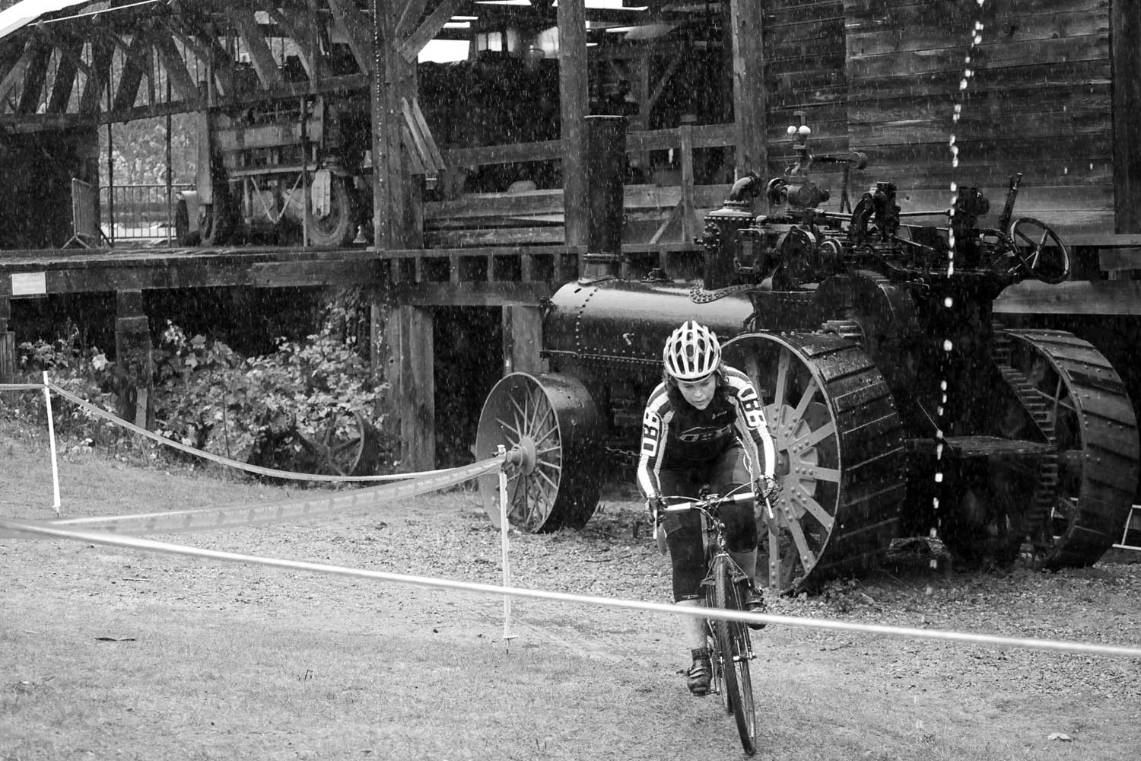

Brought to you by:
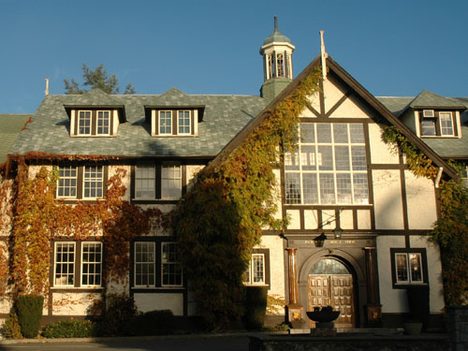


Cross on the Rock
Island Championships

Technical and Race Guide for the Shawnigan Lake School Event
November 21, 2010

Index
- Course Description
- Event Schedule
- Parking and use of the Facility
- Directions to the race
- Event Categories
- Race Numbers (a simple message from bike timing crews everywhere…..)
- Registration and License Information
- Event and Series Rules
- Course Maps

NOTE: If you can spare some time to help break down the course after our events it would be greatly appreciated. Many hands make for less work and awards can start earlier.

SPECIAL THANKS TO: Shawnigan Lake School.

Organized by:

Brought to you by the Council of Cross.

www.crossontherock.com

Race Directors: Chris Dickenson and Ian Craib
Course Designers: Chris Dickenson and Dan Scott
Host Club: Oak Bay Bikes Westshore

Series Sponsors: Phillips Beer Oak Bay Bikes
Aviawest Howard Johnson
KONA LAMBERT-Leyzene-Pedros
Saltspring Coffee OAKLEY
Frontrunners The North Face
Pro Bar Action Motorcycles
1. Course Description
The course will be “Similar” but not exactly the same as last year.
This was the description from last year:
Weighing in at over 3 kilometers, with mild climbs and relatively long straight-away and road sections, this will be one of the faster ‘Cross on the Rocks courses in recent years! Starting off on a roadway, racers will sprint off in a battle for positioning and funnel into a rough and twisty grassy field. The end of the field dumps you into a downhill thrill-ride through the forest, with a small technical section in the trees. The course will continue downhill around the Shawnigan Lake School’s new gymnasium, to the bottom of a long stairway run-up. Once remounted, the gradual ascent winds through more of the grounds, past Hogwart’s Castle, into another short wooded and rocky section. This opens to the top of the grounds, circling an active rugby field, where the barriers reside. Another few twists and a steep drop and you’re back at the start/finish – rinse and repeat!
- Event Schedule for Race
Registration: Opens at 10:00 and goes to 1:30

Pre-Riding: Course open for pre-riding from 10:00-10:55
You can also pre-ride RIGHT after previous races as long as you DO NOT PASS any rider still racing OR cross the finish line.

(NO PRE-RIDING WHEN RACES ARE IN PROGRESS)

Schedule:

10:00-1:30: Registration
10:30: Beginner Pre-ride with Ridley rider Wendy Simms (Beginners only please)
11:00: Beginners (race approx 30min for 1st person).
12:00: Open Women (race approx 40 min for 1st person)
12:03: Intermediate (race approx 40 min for 1st person)
1:00: Masters (race approx 45 min for 1st person)
2:15: Expert (race approx 60 min for 1st person)

Awards as soon after the Expert race as possible.

We will be doing the event awards and draw prizes as well as the series awards and draw prizes.

- Parking and use of the Facility (refer to the attached campus map)

  - Parking is available adjacent to the Hyde-Lay Pavilion (bldg 12), which is located beside rugby pitch #1.

  - Refer to the attached map to locate the parking and pavilion

  - Please refrain from riding your bikes on any of the fields. You will be in immediately disqualification.

  - We have been given the use of the pavilion. You will be required to remove your shoes when entering the main part of the building.

  - There are washrooms on the main floor of the pavilion and the locker rooms below.

  - When riding about the campus please respect the students and staff.

  - NOTE: race entry includes a bowl of chili (while supplies last, there should be about 60 servings…)

- Directions to Shawnigan Lake School – 1975 Renfrew Road

From Victoria:

- Take HWY-1 North over the Malahat
- Turn left at Shawnigan - Mill Bay Rd
- Turn right at Shawnigan Lake Rd
- Shawnigan Lake Rd turns slightly left and becomes Renfrew Rd
- The school is marked by both a sign and large stone gates on your right.

From Up Island:

- Take HWY – 1 South
- Turn right at Cobble Hill Rd
- Continue onto Shawnigan Lake Rd
- Turn right at Renfrew Rd
- The school is marked by both a sign and large stone gates on your right.

Google Map Link of 1975 Renfew Road:

http://maps.google.ca/maps?hl=en&source=hp&q=1975+renfrew+road&ie=UTF8&hq=&hnear=1975+Renfrew+Rd,+Cowichan+Valley+B,+Cowichan+Valley+Regional+District,+British+Columbia&ll=48.655366,-123.637712&spn=0.006775,0.013754&t=h&z=16&iwloc=A

5. EVENT CATEGORIES

Beginners: All men and women beginner racers who are not quite ready for the other categories. These racers will have done none, one or two cross races and feel they are not ready to move up. We will have a separate start and results for men and women if there are more than 5 people per gender.

NOTE: There is a feeling that after 3 races you MUST move out of beginner….that is not the case….IF you feel like you should still be racing beginner than please do so. If you are killing all the beginners each race…well then we will probably ask you to move up. Most importantly we want you to come out and have fun with as little pressure as possible.

Women: All women unless they are beginners. We will have a separate start for women just after the Masters Category.

Masters: All Masters level racers that are 35+ years old. Masters level racers may also choose to race in the Expert category if they feel they want the extra heat.. We would really like to encourage all racers over 35 years old to race the masters category instead of Intermediate to balance out the fields and give the masters category more depth.

Intermediate: Category 4 and 5 licensed road riders
(or MTB Novice or Sport)

Expert: Category 1, 2 and 3 licensed road riders (or MTB Elite Expert or Sport)

If we feel you are sandbagging then we will “politely” ask you to move up a category or two.

6. REGISTRATION INFORMATION

Sorry a Masters Cycling association, triathlon BC or other cycling association license does not cover you for this or any of our series events for this year.

There will be no pre-registration for this race.

All registration will be done on-site up to 20 minutes before each event.

Entry fee is $25 for Masters, Women, Expert and Intermediate.

For Beginners the race entry fee is $10 with or without a license. No license needed to race in Beginner category.
- Learn to race cyclocross clinic is Free for all registered racers in any category.
- NOTE: You must be registered before you do the clinic.

7. EVENT RULES
- Good sportsmanship and fair play are our number one rule!
- NO HEADPHONES. You will be DQ’ed.
- These races are designed to be fun “club” level events. This is not to say that they will not be challenging or competitive BUT we are not as serious as some other events out there.
- Riders must posses a current Cycling BC license or pay for a one day Cycling BC license ($10 at our events). Beginners exempt.
- All events are open to any type of bike; road, mountain or cross. A cross bike should be your first choice followed by a mountain bike….road bikes will not enjoy our courses…
- UCI cyclocross bike rules do not apply in our events. Run any tire width you like, flat bars are fine….if you have any questions please let us know.
- Call up at the first series event at Cumberland is RANDOM to give everyone an equal chance of getting the front line and also making it so you don’t have to go to the line so early. From event #2 onwards call up for up to the top 25 will be based on series points for those ranked and then random for all remaining racers.
- All riders will finish on lap following the leader finishing the race.
- Other than these specific rules regular cross rules and common sense will dictate everything else.
- The race organizer and or official have the final say in everything!
- At Cross on the Rock events racers are not pulled if they are lapped by the leaders of their event. All racers finish on the lead racer’s lap so you are never more than one lap down nor do you race much longer than the leader of your race. IF you do not finish on the lead racer’s lap then you will receive a DNF.

8. SERIES RULES
- Points will be given out in to all participants in each category with the exception of beginners. If you move up from intermediate or masters to expert during the year you will retain 50% of your points.
- Because we have 7 events this year we will again have a throw away for your worst result/missed event.
- We have expanded the points structure based on feedback that even the guys in the back want to beat their buddies I the series.
- 2010 Points are distributed as following:

Placing | 1 | 2 | 3 | 4 | 5 | 6 | 7 | 8 | 9 | 10 | 11 | 12 | 13 | 14 | 15
Points | 30 | 27 | 25 | 24 | 23 | 22 | 21 | 20 | 19 | 18 | 17 | 16 | 15 | 14 | 13

Placing | 16 | 17 | 18 | 19 | 20 | 21 | 22 | 23 | 24 | 25
Points | 12 | 10 | 9 | 8 | 7 | 6 | 5 | 4 | 3 | 2

2 Points will be given out to any finisher 25th and beyond.
The rider must finish the entire race and can not be a D.N.F.

The last race is double points and thus will be double the above point break down.

Series Awards are given for the top 3 in the following categories: Expert, Intermediate, Women and Masters.

Series prizes will be presented at the last event at Shawnigan Lake School….you must be there to claim them as we do not do mail outs.

9. PAST WINNERS of the Shawnigan Lake School Race

2009
Beginner Women Mary Wakefield
Beginner Men Liam Farrar
Intermediate Men Geoff Pendrel
Masters Men Justin Mark
Open Women Mical Dyck
Expert Craig Richey

Full 2009 Results here: www.crossontherock.com

Organized by:

Brought to you by the Council of Cross.

www.crossontherock.com

Race Directors: Chris Dickenson and Ian Craib

Course Designers: Chris Dickenson and Dan Scott

Host Club: Oak Bay Bikes Westshore

Series Sponsors: Phillips Beer Oak Bay Bikes
Aviawest Howard Johnson
KONA LAMBERT-Leyzene-Pedros
Saltspring Coffee OAKLEY
Frontrunners The North Face
Pro Bar Action Motorcycles

This Cyclocross Series is Organized by the Cross Council:
With the following cycling clubs: VICC, Experience Cycling Club, UROC, Arrowsmith MTB Club, Alberni Valley Riders and IRC

Supported by:
OBB Victoria, Westshore and Nanaimo
Trail Bikes in Courtenay
Experience cycles in Duncan
Frontrunners in Nanaimo
Straight Up Cycles in Victoria
Dodge City Cycles in Cumberland
Ozzie’s Cycles in Port Alberni

Sanctioned by:
Cycling BC

Actual set up course will be slightly different from what is shown in this map……but close.

Traveling up the road and going counter clockwise to start.

